Cape Manor 25 July 2018, Water of Leith Walkway, Stockbridge to Dean Village

Guide Notes

- Key
Places of interest / to mill around are in bold.
Suggested route / directions are in itallics.
Cape Connections are marked by asterisks (***).

Meet in The Baillie Bar in Stockbridge between 19.30 and 20.00.
Leave Baillie at 20.00.
Head down Kerr Street in to the heart of Stockbridge.
Turn left on to Saunders Street (avoiding crossing the bridge).
Mention the duck race.
Mention Sir and Lady Kowloon as you walk along Saunders Street with The Water on your right. Recount the classic “most expensive bottle of wine in the cellar” story and any other memories Knights have.

Stockbridge
General chat…
In modern scots language ‘stocc brycg’, means timber bridge.
Originally a small outlying village, it was incorporated into the City of Edinburgh in the 19th century
*** Cape Connection: Stockbridge has strong links with Sir Discovery (Henry Raeburn, portrait painter) (whose house was viewed as part of the New Town Manor May 2016 (at York Place).
Sir Discovery owned two adjoining estates which now form part of Stockbridge, namely Deanhaugh and St Bernard's estates.
Sir Discovery lived in St. Bernard's House until his death in 1823. (The house was demolished in 1826 to make way for the east side of Carlton Street).
Anne Street in Stockbridge was named after Sir Discovery’s wife.
*** Cape Connection: Sir Discovery’s (last will and) Testament refers to 'knight' (https://www.nrscotland.gov.uk/files//research/famous-scots/raeburn-sir-henry-will-transcript.pdf)
Continue upriver along Saunders Street through/under Park Stairs which some have said provide a Harry Potter-eaque inspiration.
Continue upriver (with the river on your right) in the direction of St Bernard’s Well.

St Bernard’s Well
Head for St Bernard’s Well. This mineral water well was built around 1790 when the Cape Club was in its prime.
*** Cape Connection: Alexander Nasmyth (Sir Thumb) was commissioned to design a new pump room and ornate structure over the well (http://capesociety.org/member.famous.php)
The current statue is of Hygieia: goddess of healing (connected to the belief the mineral water from the well had medicinal qualities... perhaps with whisky)
*** Cape Connection: the football team named St. Bernard's took its name from the well. Some Knights or at least friends of Knights played for St Bernard’s.
Head further along the path (river to your right) in the direction of St George’s Well.

St George’s Well
https://www.pinterest.co.uk/pin/569494315362459939
The well was built in 1810 and named in honour of the Jubilee of King George III.
Old pic
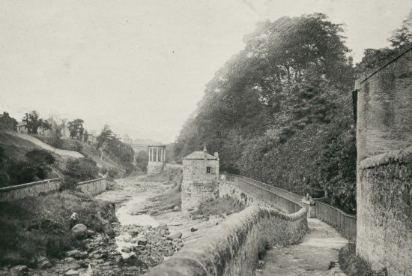

New pic
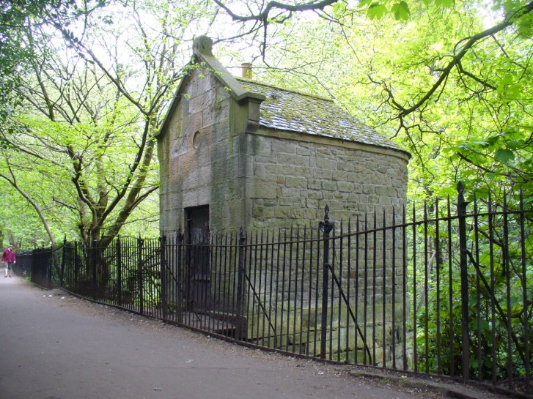

Continue up river to the Dean Bridge.

Dean Bridge
Mill around under the bridge.
The Dean Bridge spans the Water of Leith in the city of Edinburgh on the A90 road to Queensferry on the Firth of Forth. It carries the roadway, 447 feet (136 m) long and 39 feet (12 m) broad, on four arches rising 106 feet (32 m) above the river. The bridge was one of the last major works before retirement of the bridge designer, civil engineer Thomas Telford, and was completed in 1831.
*** Cape Connection: Telford had a hand in the building of London Bridge, visited by the Cape Society on a recent MMM.
Before the bridge was built the river had been crossed since medieval times at a ford, later by a single-arch stone bridge near the same spot, at the foot of Bell's Brae in the Dean Village (your next stop).
Dean Bridge was featured in Ian Rankin's fictional book Strip Jack, in which a woman is found dead in the river underneath the bridge. It also features as a location in the second book of the Peter May Lewis trilogy, The Lewis Man, in which a 1950s schoolboy dare results in a fatality.
Continue to head up Miller Row (river on right) towards the stone bridge which crosses the Water of Leith (Dean Path crossing).
Mill around the Dean Path crossing (car and foot bridge at the foot of Bells Brae and end of Miller Row (which you walked up)). Mention mills in the Dean (from dene, meaning 'deep valley') Village declined with the opening of more modern mills in Leith
Cross over the stone bridge and the Water of Leith, take the first left on to Damside, first left again (still on Damside) and go over the wooden footbridge, crossing the river again (after only a relatively short distance) on to Hawthornbank Lane. Pause on the footbridge to view Well Court.

Well Court
Admire Well Court, finished in 1886.
*** Cape connection: A possible source for the design of the tower is the 17th century Earl’s Palace in Kirkwall
The accommodation in Well Court was originally intended for local workers in the Dean Village area. An advertisement from the 1880s described Well Court as, “providing homes of two and three rooms with conveniences, let to a respectable class of working men at rentals of £7 to £12 per annum.” (Bit more than that now: 3 beds for £0.5 million.)
*** Cape Connection: When they were built around 1886, although housing conditions were relatively good, the residents were under strict rules and could be locked out if they stayed out at night too long. Could’ve done with a ruse like “doubling the cape”.

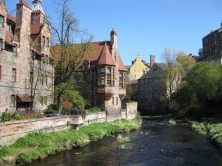

Having crossed over the footbridge to the side of the river you’ve been on most of the Manor, keep right, up the hill (still Hawthornbank Lane).
Relax in the West End Hotel (Palmerston Place) or Thistle Hotel (Manor Place). Be convivial.
Manor ends here.

